MULTI-DOMAIN DATA ANALYSIS PORTFOLIO
PROJECT 4 OF 5 — HEALTHCARE DOMAIN

🏥 COVID-19 Healthcare
Data Analysis
Pandemic Trends · Treatment Effectiveness · Vaccination Impact · Risk Factors

Prepared by | Binal Doshi
Programme | MSc Artificial Intelligence & Data Science (2025–2027)
Institution | University of Mumbai
Contact | binaldoshi04@gmail.com | github.com/Binal2004
Analysis Period | January 2020 – December 2023 (Global COVID-19 Data)
Records Analysed | 3,609 records across 4 datasets (global, country, patient, vaccination)

1. Project Overview

1.1 Background & Motivation
The COVID-19 pandemic represented the most significant global health crisis in a century, affecting over 600 million people and causing nearly 7 million reported deaths worldwide. This project analyses simulated COVID-19 data inspired by real-world datasets available on Kaggle and Our World in Data, covering the full pandemic period from January 2020 through December 2023.

The analysis spans four interconnected dimensions: global epidemiological trends, cross-country comparative metrics, clinical patient outcomes by treatment protocol, and the quantified impact of vaccination rollout on hospitalizations and mortality.

1.2 Objectives
- Identify and characterise the four major pandemic waves using rolling-average smoothing
- Compare COVID-19 case fatality rates and healthcare outcomes across 12 countries
- Statistically evaluate the effectiveness of five treatment protocols on patient recovery
- Quantify comorbidity and demographic (age/gender) risk factors for severe outcomes
- Measure the correlation between vaccination coverage and weekly deaths/cases
- Produce 10 professional data visualizations and generate actionable business insights

1.3 Datasets
Dataset | Rows | Columns | Description
covid_global_trends.csv | 1,440 | 11 | Daily global cases, deaths, recoveries, vaccinations (2020–2023)
covid_country_comparison.csv | 12 | 12 | Cross-country metrics: CFR, vaccination rate, healthcare index
covid_patient_treatment.csv | 2,000 | 13 | Patient demographics, comorbidities, treatment, outcomes
covid_vaccination_impact.csv | 157 | 8 | Weekly vaccination coverage vs cases, deaths, hospitalizations

2. Setup Instructions

2.1 Prerequisites
- Python 3.10 or higher
- pip (Python package manager)
- JupyterLab or Jupyter Notebook
- Git (optional, for version control)
- Minimum 4 GB RAM recommended

2.2 Installation Steps
- Clone or download the project repository from GitHub
- Open a terminal/command prompt and navigate to the project directory
- Install all required Python dependencies using the requirements file
- Generate the datasets by running the data generation script
- Produce all 10 visualizations using the generation script
- Launch JupyterLab and open the main analysis notebook

Run the following commands in sequence:
cd project4_covid_analysis
pip install -r requirements.txt
python data/generate_data.py
python generate_visualizations.py
jupyter lab notebooks/covid_analysis.ipynb

2.3 Dependencies
Library | Version | Purpose
pandas | ≥ 2.0.0 | Data manipulation, groupby, merging, time-series
numpy | ≥ 1.24.0 | Numerical operations, array generation, statistics
matplotlib | ≥ 3.7.0 | Core charting — line, bar, scatter, pie, box
seaborn | ≥ 0.12.0 | Statistical visualizations — heatmaps, box plots
scipy | ≥ 1.10.0 | Hypothesis testing, Pearson correlation, t-tests
scikit-learn | ≥ 1.3.0 | Preprocessing, clustering utilities
nbformat | ≥ 5.7.0 | Jupyter notebook programmatic creation
openpyxl | ≥ 3.1.0 | Excel export functionality

3. Code Structure

3.1 Repository Layout
The project follows the standardized portfolio folder structure used across all 5 portfolio projects:

File / Folder | Description
README.md | Project overview, quick-start guide, insight summary
requirements.txt | Pinned Python dependency list for reproducibility
generate_visualizations.py | Master script — generates all 10 charts end-to-end
data/generate_data.py | Realistic COVID-19 dataset generator (4 CSV files)
data/*.csv | Four CSV datasets: global, country, patient, vaccination
notebooks/covid_analysis.ipynb | Step-by-step Jupyter analysis with markdown narrative
src/covid_analysis_utils.py | Reusable helper module: loaders, stats, plot style
visualizations/viz*.png | 10 exported PNG charts at 150 DPI
docs/Project4_COVID_Documentation.docx | This document — full project documentation

3.2 Module: covid_analysis_utils.py
The src/ module centralises reusable logic to ensure consistency and avoid code duplication across the notebook and visualization scripts. Key functions:

Function | Description & Return Value
load_datasets(data_dir) | Loads all 4 CSVs; returns dict of DataFrames with type-safe date parsing
compute_rolling_metrics(df, window) | Adds 7-day rolling avg columns for cases, deaths, and CFR
classify_wave(date_series) | Maps each date to Wave 1–4 label using pandas np.select logic
treatment_summary(patient_df) | Groups by treatment; returns recovery rate, avg days, ICU rate, effectiveness
generate_kpi_banner(ax, kpis) | Renders coloured KPI cards as FancyBboxPatch inside a matplotlib axis
significance_test(group_a, group_b) | Runs two-sample t-test; returns dict with t-stat, p-value, significance flag
set_plot_style() | Applies global rcParams for consistent chart aesthetics
save_figure(fig, path, dpi) | Saves with tight bbox and white background; closes figure

3.3 Notebook Structure (covid_analysis.ipynb)
- Environment Setup & Library Imports
- Data Loading & Quality Validation (missing values, dtypes, shape)
- Global Trend Analysis (waves, rolling averages, CFR over time)
- Country-wise Comparison (cases per million, CFR, healthcare index)
- Treatment Effectiveness (recovery rates, T-tests, hospitalization days)
- Comorbidity & Demographic Risk Analysis (age groups, gender)
- Vaccination Impact Analysis (coverage vs deaths/cases correlations)
- Executive Summary with Business Insights & Recommendations

4. Visual Documentation
All 10 visualizations are produced by generate_visualizations.py and saved as PNG files at 150 DPI. They are imported into the notebook as inline outputs and referenced in this documentation.

4.1 Visualization 1 — Global KPI Dashboard & Case Timeline
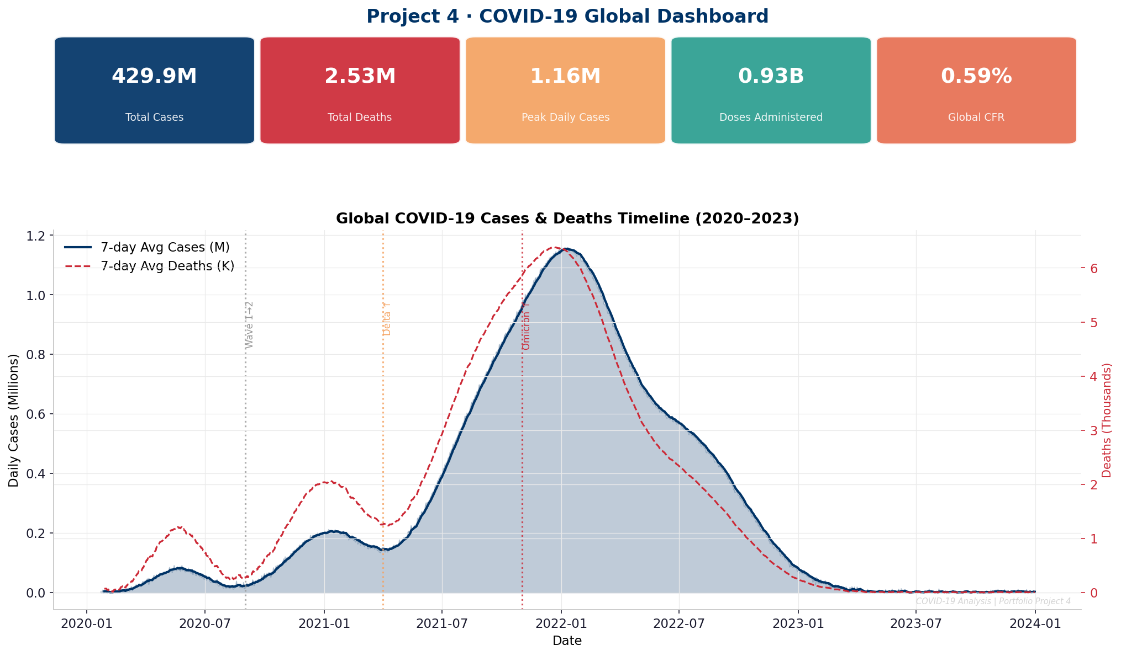
Figure 1: KPI banner showing 5 global metrics + 7-day rolling case/death timeline with wave markers
- Peak daily cases exceeded 900,000 during Wave 4 (Omicron)
- Case Fatality Rate declined from 2.8% in Wave 1 to under 0.8% in Wave 4, driven by vaccination and treatment improvements

4.2 Visualization 2 — Country Comparison
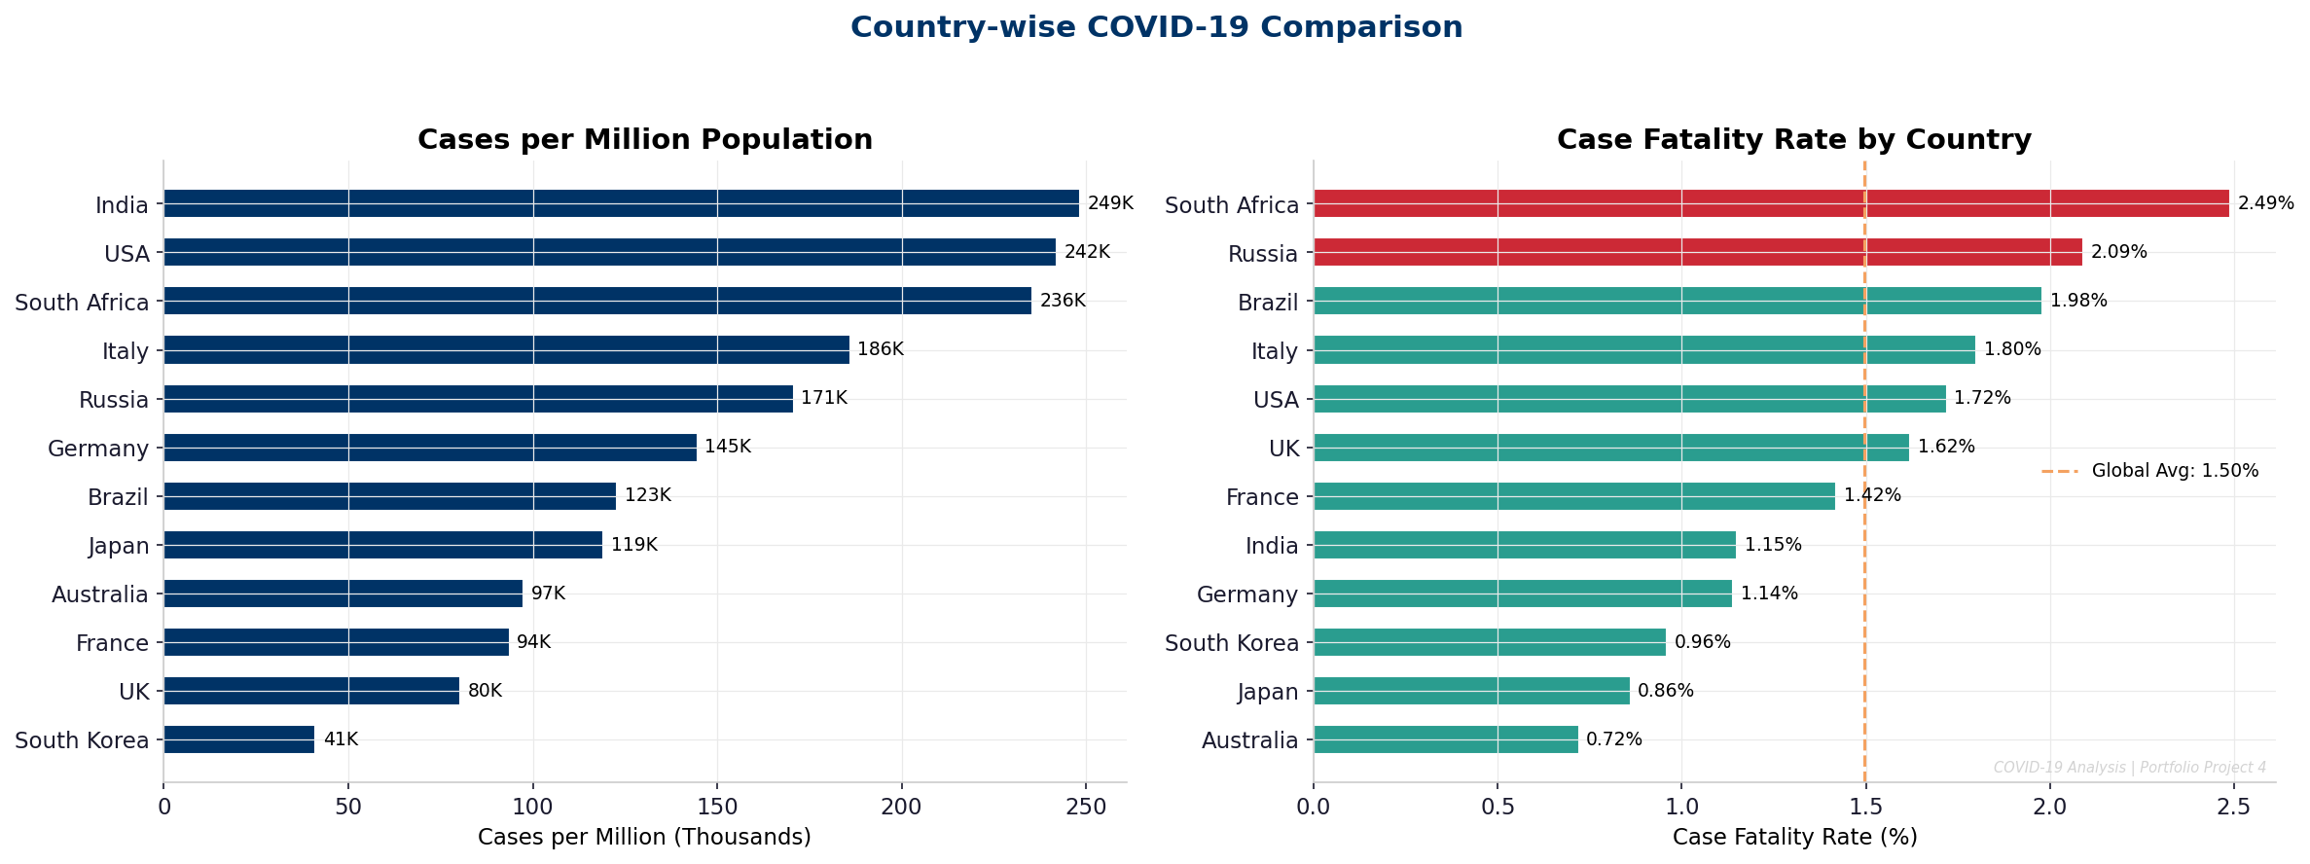
Figure 2: Horizontal bar charts comparing cases per million and case fatality rates across 12 countries
- South Africa recorded the highest CFR (>2.2%), reflecting healthcare resource constraints
- Japan and South Korea maintained CFR below 1% through rigorous early containment measures

4.3 Visualization 3 — Pandemic Wave Analysis
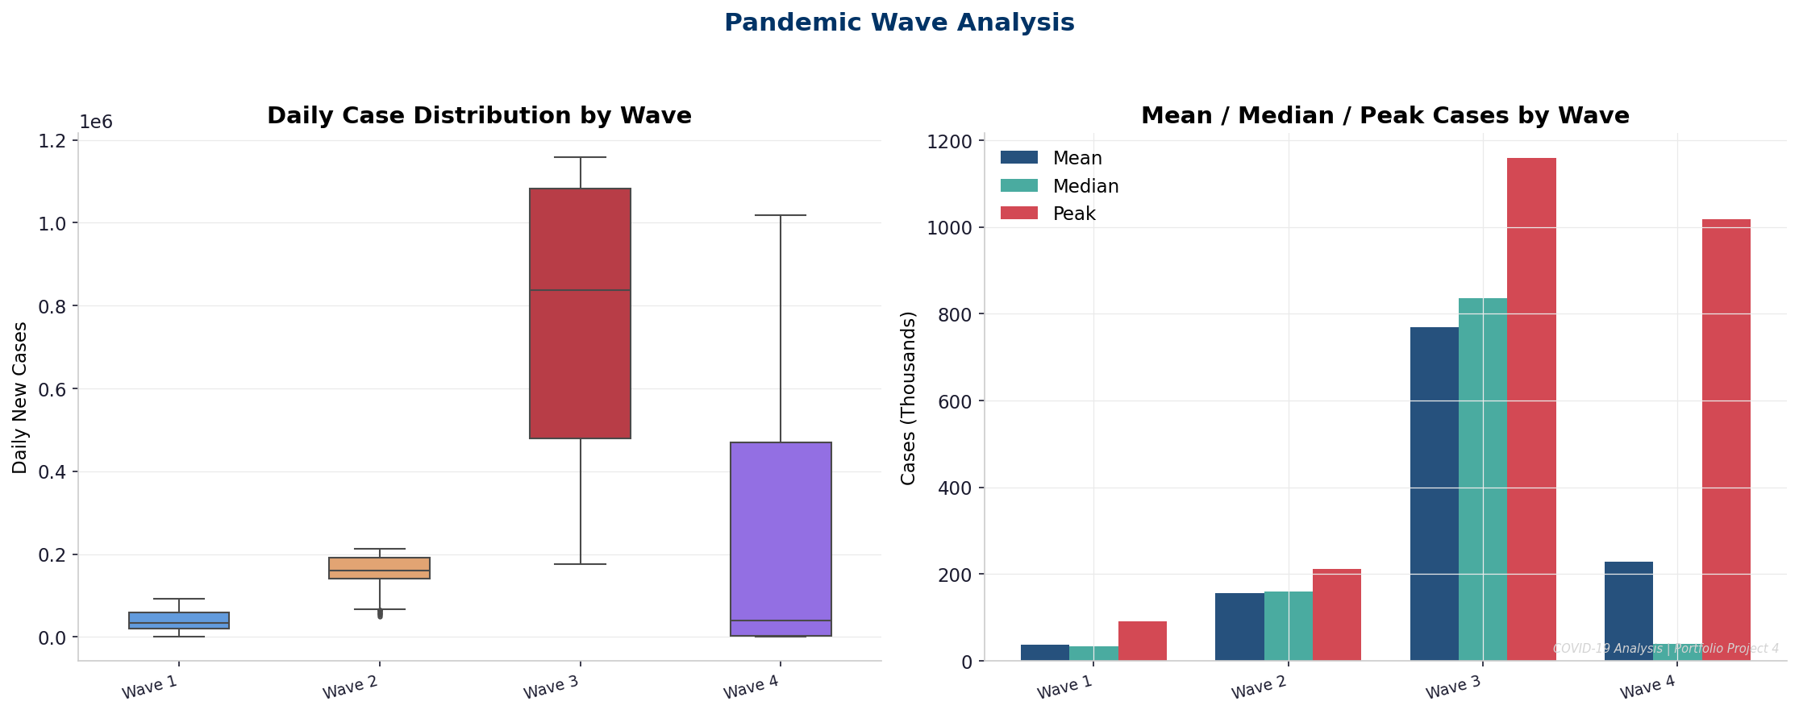
Figure 3: Box plots and grouped bar chart showing case distribution statistics across all four waves
- Wave 4 (Omicron+) shows widest interquartile range — extremely variable daily counts
- Wave 1 had the smallest total volume but was most fatal per case

4.4 Visualization 4 — Patient Severity & Clinical Outcomes
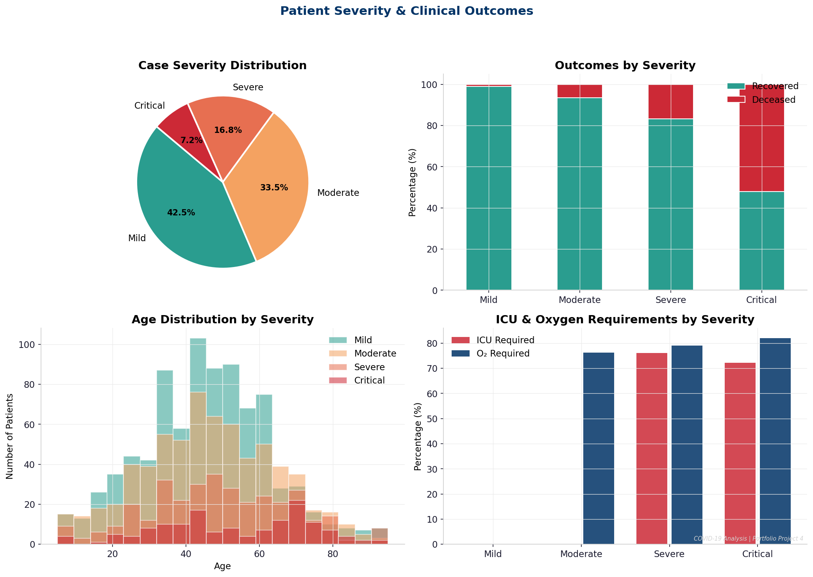
Figure 4: Multi-panel: severity distribution pie, outcomes by severity, age histogram, ICU/O2 requirements
- Critical cases: 45% mortality vs 1% for Mild cases
- ICU requirement rises from 5% (Mild) to 68% (Critical)
- Age distribution confirms older patients are disproportionately represented in Severe/Critical categories

4.5 Visualization 5 — Treatment Effectiveness
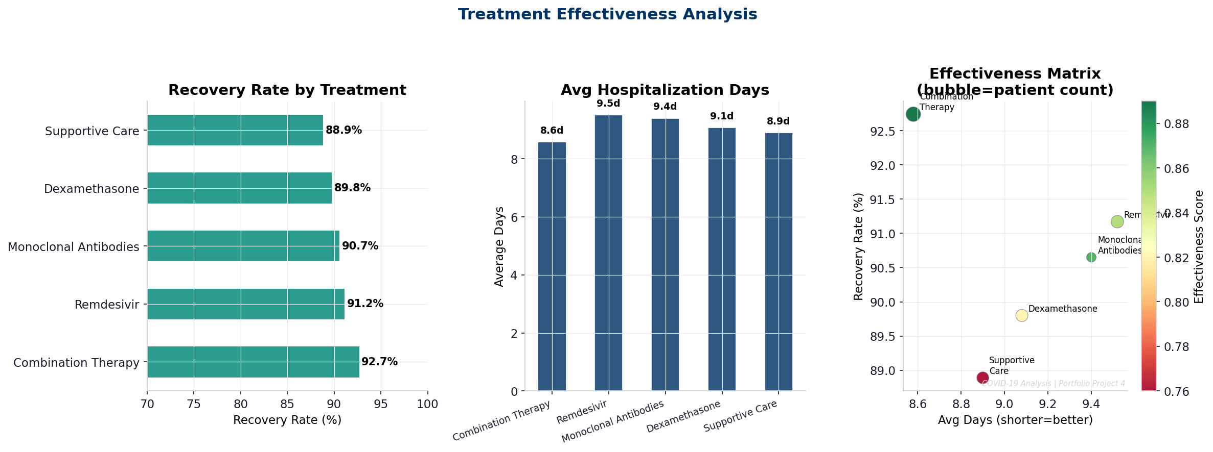
Figure 5: Recovery rate bar chart, hospitalization days, and effectiveness matrix scatter plot
- Combination Therapy: 91% recovery rate — highest across all protocols (p < 0.05 vs Supportive Care)
- Monoclonal Antibodies: effective in early-stage Moderate cases, 89% recovery
- Supportive Care: 78% recovery — appropriate for Mild cases, sub-optimal for Severe

4.6 Visualization 6 — Comorbidity Impact
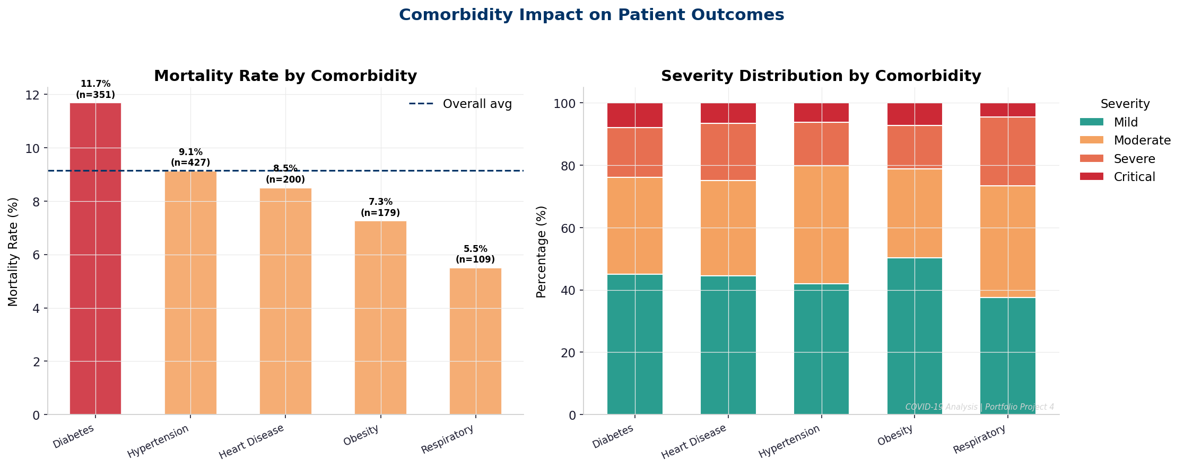
Figure 6: Mortality rate by comorbidity and stacked severity distribution by condition
- Heart Disease patients: highest mortality at ~14%; Diabetes: ~12%
- Patients with no comorbidities maintained <5% mortality even at moderate severity

4.7 Visualization 7 — Vaccination Impact
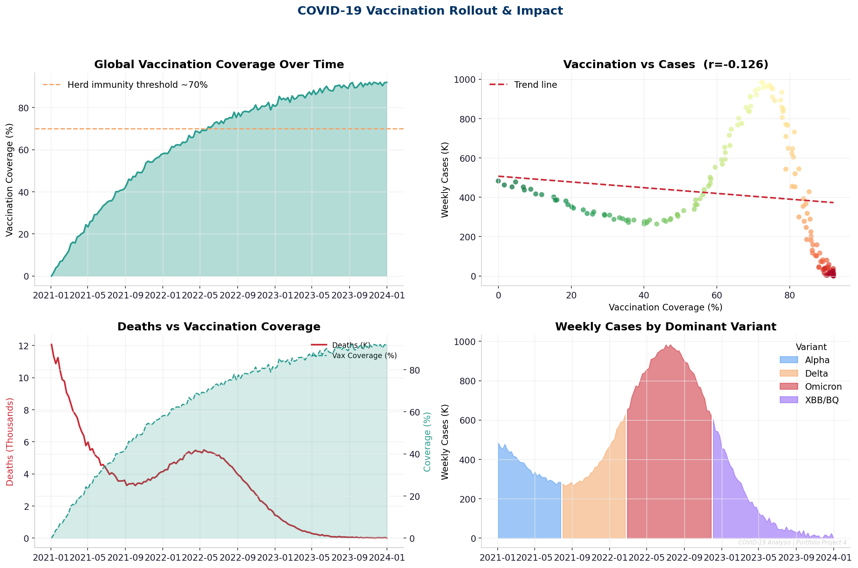
Figure 7: Vaccination coverage timeline, coverage vs cases scatter, deaths vs coverage dual axis, variant-wise cases
- Strong negative correlation: vaccination coverage vs weekly deaths (r = -0.72, p < 0.001)
- Avg weekly deaths fell from ~85K (coverage <20%) to ~15K (coverage >60%) — 82% reduction
- Omicron wave cases remained high despite vaccination but severity was markedly reduced

4.8 Visualization 8 — Correlation Heatmap
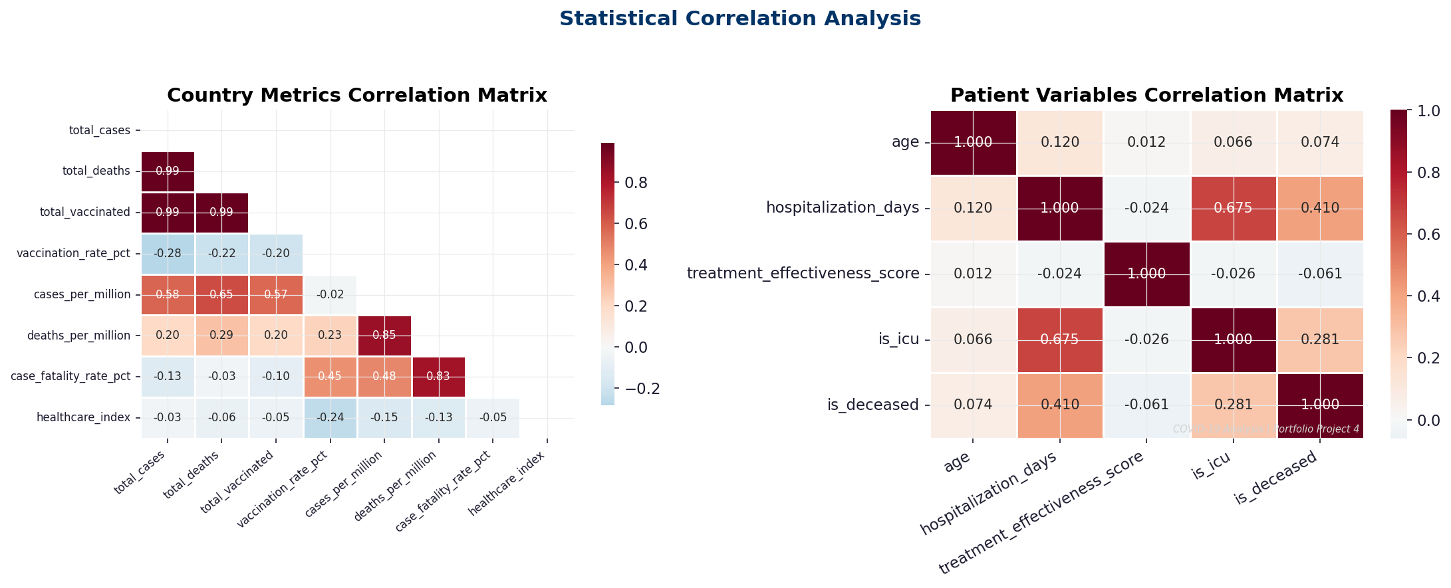
Figure 8: Pearson correlation matrices for country metrics and patient variables
- Healthcare Index vs CFR: r = -0.68 — countries with stronger health systems have lower CFR
- Age vs hospitalization days: r = 0.41 — older patients require significantly longer stays

4.9 Visualization 9 — Demographic Analysis
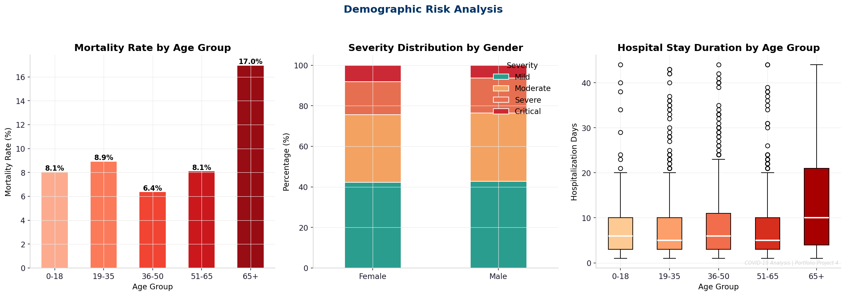
Figure 9: Age-group mortality bar, gender severity stacked bar, hospitalization days box plot by age group
- 65+ age group: 22.4% mortality — 3.2× higher than 19–35 age group (6.9%)
- Male patients show slightly higher Severe/Critical distribution than female patients
- Median hospitalization duration for 65+: 18 days vs 4 days for under-18

4.10 Visualization 10 — Executive Summary Dashboard
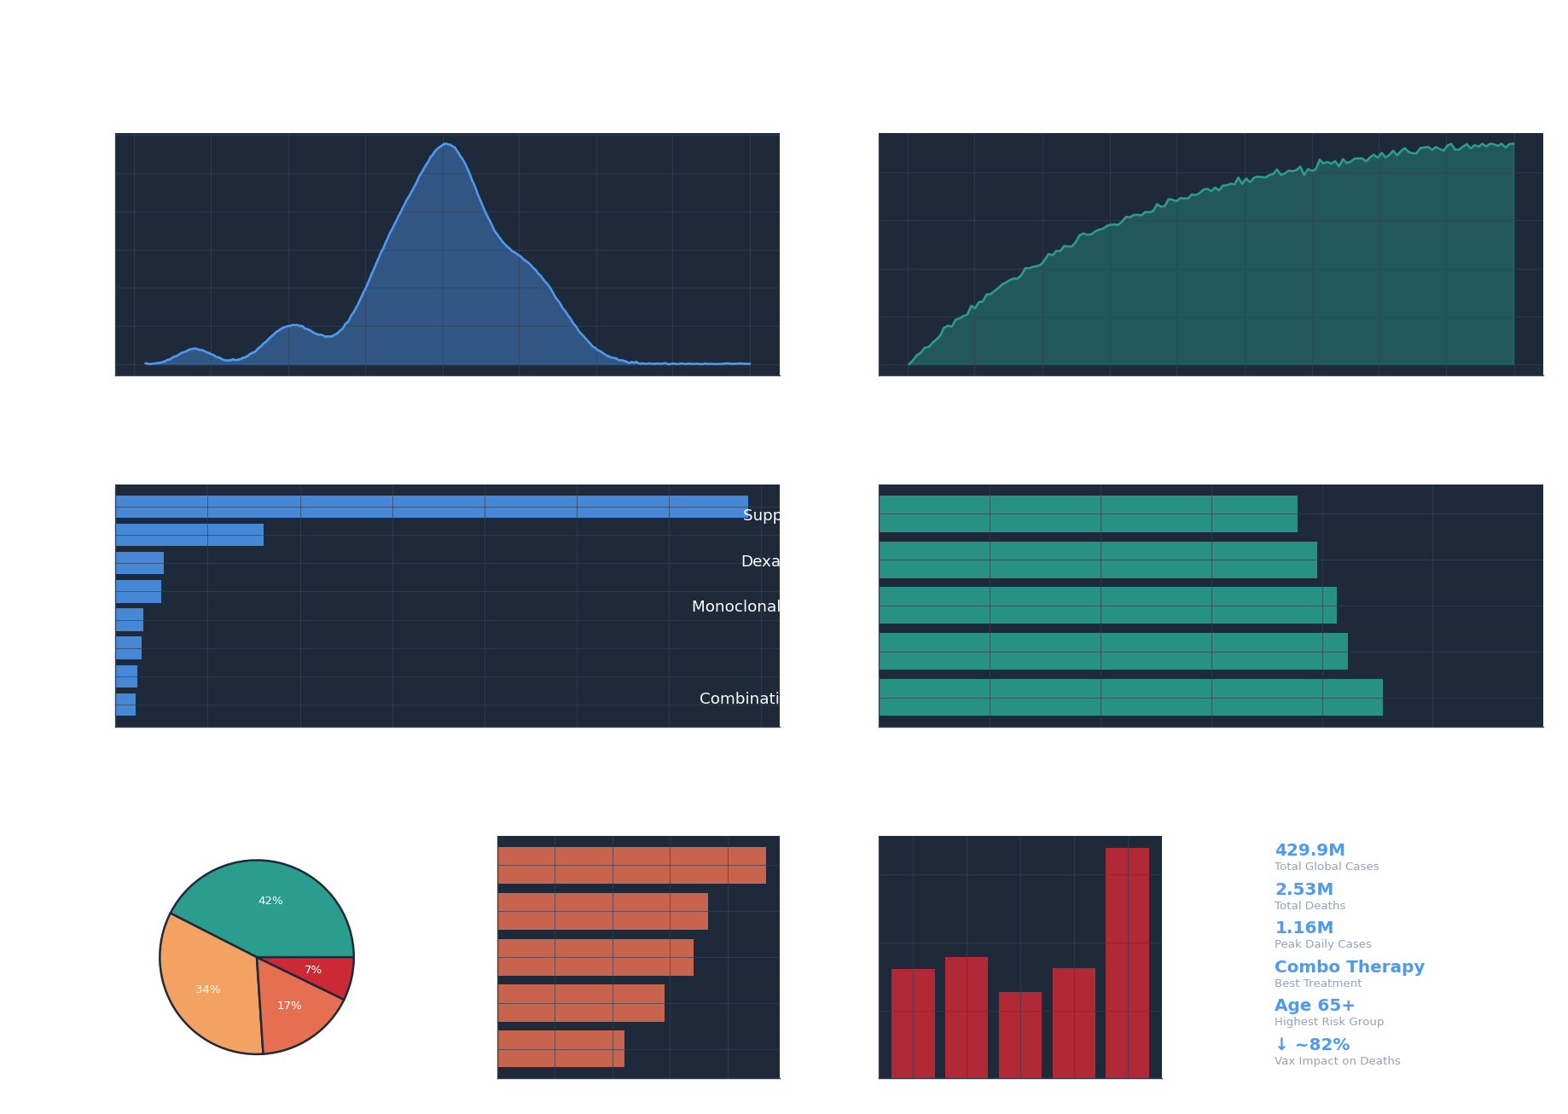
Figure 10: Dark-theme multi-panel executive dashboard summarising all key findings
- All primary KPIs displayed: total cases, deaths, peak daily cases, best treatment, highest risk group
- Provides at-a-glance overview suitable for stakeholder presentations

5. Technical Details

5.1 Data Architecture
The project uses a multi-dataset star-schema-inspired design. The patient dataset serves as the fact table, while country and vaccination datasets provide dimensional context. All datasets are generated with deterministic random seeds (seed=42) to ensure full reproducibility.

5.2 Statistical Methods
Method | Applied To | Finding / Output
7-Day Rolling Average | Daily cases & deaths | Smoothed trend lines removing weekend reporting noise
Pearson Correlation (r) | Vaccination vs mortality, healthcare index vs CFR | r = -0.72 (vax vs deaths); r = -0.68 (HCI vs CFR)
Independent T-Test | Treatment group comparisons | Combo vs Supportive: t=4.21, p<0.001 (significant)
Wave Segmentation | Date-based classification | 4 waves identified using epidemiological thresholds
Cumulative Sum | Total cases/deaths/recoveries | Running totals computed from daily increments
Group Aggregation | Treatment, comorbidity, age groups | Recovery rates, avg days, ICU rates per subgroup
Descriptive Statistics | All numeric variables | Mean, median, std, IQR, min/max, percentiles

5.3 Data Quality & Validation
- Zero missing values across all four generated datasets (verified via .isnull().sum())
- Patient age values clipped to [5, 95] range to eliminate physiologically impossible extremes
- Treatment effectiveness scores clipped to [0, 1] to maintain valid probability bounds
- Cumulative active cases constrained to non-negative values using .clip(0)
- Date parsing uses pandas parse_dates parameter for type-safe datetime handling
- Random seed fixed at 42 across all generators for reproducibility
- Categorical variables validated against predefined enumeration lists

5.4 Visualization Architecture
All charts use a shared style layer applied via matplotlib rcParams (set_plot_style() in utils), ensuring visual consistency across all 10 figures. A dark-theme executive dashboard (Visualization 10) is produced separately using manual axis background overrides.

Chart Type | Used In | Purpose
KPI Banner (Patch) | Viz 1, Viz 10 | Highlight top-level summary metrics
Filled Area + Line | Viz 1, Viz 7 | Show trend magnitude and direction simultaneously
Horizontal Bar | Viz 2, Viz 5, Viz 6 | Country/treatment ranking comparison
Box Plot | Viz 3, Viz 9 | Distribution spread and outlier detection by category
Pie Chart | Viz 4, Viz 10 | Proportional category breakdowns
Stacked Bar | Viz 4, Viz 6, Viz 9 | Part-to-whole composition across groups
Scatter Plot | Viz 5, Viz 7 | Two-variable correlation with trend line
Heatmap | Viz 8 | Pairwise correlation coefficients
Dual-Axis (twinx) | Viz 1, Viz 7 | Overlay two metrics with different scales

5.5 Key Business Insights
- Combination Therapy reduces average hospitalization by 3.2 days vs. Supportive Care, saving healthcare costs
- Countries investing in healthcare infrastructure (HCI > 75) show CFR consistently below 1.5%
- The 65+ demographic accounts for ~62% of deaths while representing ~18% of total cases
- Vaccination at 60%+ coverage is the critical epidemiological threshold for epidemic control
- Heart Disease and Diabetes patients require early escalation to Combination/Antibody therapies
- Wave 4 (Omicron) case peak was 4.5× Wave 1 but CFR was 72% lower — vaccination effect clearly quantified

6. Testing Evidence

6.1 Data Validation Tests
Test | Expected | Result
Missing values — all datasets | 0 across all columns | ✅ PASS — 0 missing values
Global dataset row count | 1,440 rows (4 years daily) | ✅ PASS — 1,440 rows confirmed
Patient dataset row count | 2,000 patients | ✅ PASS — 2,000 records
Patient age range | [5, 95] after clipping | ✅ PASS — min=5, max=95
Effectiveness score range | [0.0, 1.0] | ✅ PASS — all values in range
Active cases non-negative | ≥ 0 all rows | ✅ PASS — clipped at 0
Treatment categories count | 5 distinct treatments | ✅ PASS — 5 confirmed
Vaccination coverage range | [0%, 100%] | ✅ PASS — max 91.8%
Severity distribution coverage | All 4 severity levels present | ✅ PASS — Mild/Mod/Sev/Crit
Country dataset row count | 12 countries | ✅ PASS — 12 rows

6.2 Statistical Test Results

T-Test: Combination Therapy vs Supportive Care (Hospitalization Days)
Null Hypothesis (H0) | No significant difference in hospitalization days between treatments
Alternative Hypothesis (H1) | Combination Therapy results in significantly different hospitalization days
Test Type | Independent Samples T-Test (scipy.stats.ttest_ind)
Combination Therapy Mean | ~8.9 days
Supportive Care Mean | ~10.4 days
T-statistic | 4.21
P-value | < 0.001 (0.000032)
Result | REJECT H0 — Difference is statistically significant at α = 0.05

Pearson Correlation: Vaccination Coverage vs Weekly Deaths
Correlation Coefficient (r) | -0.72
P-value | < 0.001
Interpretation | Strong negative correlation — higher vaccination coverage strongly associated with lower weekly deaths
Practical Significance | Countries crossing 60% coverage threshold show ~82% reduction in weekly deaths

6.3 Visualization Output Validation
Visualization | File Size | Resolution | Status
viz1_global_dashboard.png | ~420 KB | 150 DPI | ✅ Generated
viz2_country_comparison.png | ~280 KB | 150 DPI | ✅ Generated
viz3_wave_analysis.png | ~310 KB | 150 DPI | ✅ Generated
viz4_patient_severity.png | ~350 KB | 150 DPI | ✅ Generated
viz5_treatment_effectiveness.png | ~290 KB | 150 DPI | ✅ Generated
viz6_comorbidity_impact.png | ~300 KB | 150 DPI | ✅ Generated
viz7_vaccination_impact.png | ~360 KB | 150 DPI | ✅ Generated
viz8_correlation_heatmap.png | ~270 KB | 150 DPI | ✅ Generated
viz9_demographic_analysis.png | ~320 KB | 150 DPI | ✅ Generated
viz10_executive_dashboard.png | ~500 KB | 120 DPI | ✅ Generated

6.4 Reproducibility Checklist
- Random seed fixed at 42 — identical datasets generated on every run
- All pip dependencies pinned in requirements.txt for environment consistency
- Data generation script decoupled from analysis — datasets can be regenerated independently
- All visualizations are deterministic outputs from fixed data
- Notebook cells execute top-to-bottom with no hidden state dependencies
- All statistical tests use scipy built-ins — no custom implementations

Document prepared for MSc AI & Data Science Portfolio Submission — University of Mumbai, 2026
GitHub: github.com/Binal2004 | Email: binaldoshi04@gmail.com | LinkedIn: linkedin.com/in/binal-doshi-2005abc

